**Manuals for ‘Manage Enquiry’**

**Brief of the ‘Manage Enquiry’ –** This is the page where we can manage the enquiry of following form.

1. Feedback
2. Complaint
3. Estimate request
4. Quick enquiry

**1. How to manage enquiry -.**

Steps:

1. Login to the site and go to ‘Masters’ tab and click on ‘Manage Enquiry’.
2. On ‘Manage Enquiry’ page, we have to select the enquiry type and click on ‘Show’ button.
3. On this page, all the entry of respective for will display, we can edit and delete the existing records.

1.

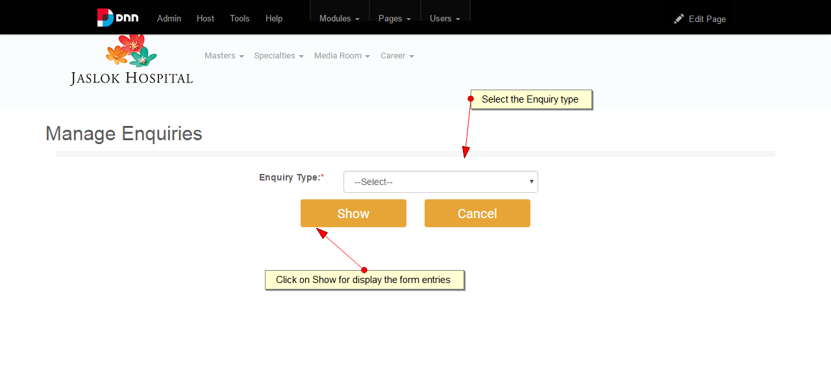

2.

